Genetic Algorithms

Intelligent Systems

Rodrigo A. Chavez M. i6165844; Lillian Wu i6151962

2020

# Genetic Algorithms

For this assignment we created two genetic algorithms which follow the standard procedure, we first define how the genes of an individual will be tailored to an specific problem, then we create a population and inside a loop we first record the population and measure the fitness of the individuals to find an early stop or we just continue the loop for *n* iterations, after measuring the performance, we do the selection of the best individuals using elitism and continue by applying crossover which is immediately followed by the mutation step after that the loop goes back to the beginning. For our implementation we create a list called world which contains the parameters of the simulation along with the other information required for the specific problem (like the items weight and value in the knapsack problem).

# Knapsack

For this problem the genetic algorithm follows the structure mentioned before, the genes are a list of binary numbers of a corresponding size to the amount of items we can put in the bag, the index in the list correspond to an item where having a value of 1 means it’s in the bag and the opposite if the value is 0. We use elitism to select the parents before the crossover method, which goes gene by gene checking if we should swap the gene between parents with a probability of 0.5. Then in the mutation if a gene is selected to be mutated, we flip the value and then the next iteration starts.

As suggested in the lab documentation we have unique items and the rewards are also a range of unique numbers from 1 to n, n being the total amount of items, with random weights from 1 to 10. Per experiments we did 1000 iterations of the main loop, with the following combination of parameters:

|  |  |  |  |
| --- | --- | --- | --- |
| Items | 10 | 15 | 30 |
| Population size | 10 | 50 | 100 |
| Elitism % | 10% | 20% |  |
| Crossover probability | 0.7 | 0.9 |  |
| Mutation probability | 0.05 | 0.1 |  |

The results suggest that an elitism of 10% performs better than 20% with a sufficient big population while the values of crossover don’t bring any meaningful improvement to the fitness, the mutation probability seems to greatly affect the fitness of the overall simulation.

# Traveling Salesman

Our Genetic Algorithm for the traveling salesman problem has the same structure as described at the beginning, for this problem each gene has a length corresponding to the number of cities/nodes and it represents a path were no city is visited twice. This constraint made the problem a bit more difficult than the knapsack one since we could not simply flip 0s and 1s but after some thinking we came up with a crossover method. The crossover works by randomly selecting 2 parents then for parent A get a random index (0 to list length) from the genes list and a random length of genes (index to list length) we will use as base for child A respecting the positions, then we fill the rest of genes of child A using the genes of Parent B by keeping the order in which they appear at Parent B while checking they don’t belong to the chunk of genes we took from parent A. For the mutation step we go gene by gene checking if it should mutate, if that’s the case then we swap the gene with a random number (within the possible range) and swap the gene that had the random number with the gene that mutated (to maintain a path that visits only one city). After doing this per every gene we go back to the beginning of the loop while doing it for n (5,000 during experiments) iterations.

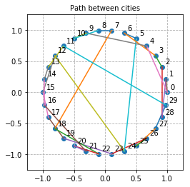Each experiment consisted of 5000 iterations with an early stopping parameter that measured the fitness being less than 2*pi since all the cities lie equidistantly in the perimeter of a unit circle.

Figure 1 - Example of cities distribution and path

For the experiments of the GA for the TSP we tested the following list of parameters: cities amount, population size, elitism percentage, crossover probability and mutation probability. We had the problem of deciding which values we would plot and report, after testing many values we decided to go for a complete combination of the following parameters generating 72 simulations with 5000 iterations each:

|  |  |  |  |
| --- | --- | --- | --- |
| Cities/Nodes | 10 | 25 | 40 |
| Population size | 10 | 50 | 100 |
| Elitism % | 10% | 20% |  |
| Crossover probability | 0.7 | 0.9 |  |
| Mutation probability | 0.05 | 0.1 |  |

These values were chosen because we saw they represented a good variation of results depending on the combination of them but overall we can see some expected results like the more cities the more iterations are necessary to reach a better result but we can also observe a clear difference of diversity across all experiments depending on the mutation probability where generally lines blue and green have less diversity but also are closer the optimum value, by tuning this parameter in conjunction with the crossover probability we can get better results. Also, we saw in the experiments how elitism must remain relatively small in proportion to the population, otherwise a lot of bad genes will get passed in crossover and might not find the optimum value. Finally, we can see how when there is a high number of cities (like 40), the fitness of lines orange and red oscillated far from the optimum meaning that better parameters like mutation and elitism are required.

Experiments Graphs – Knapsack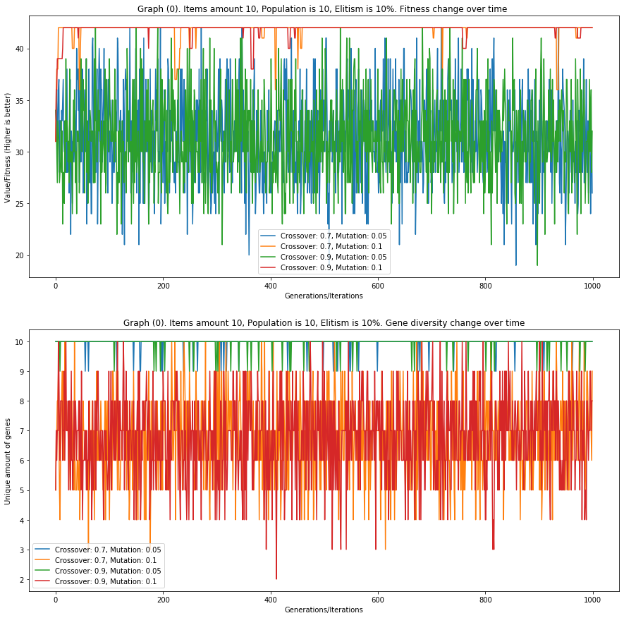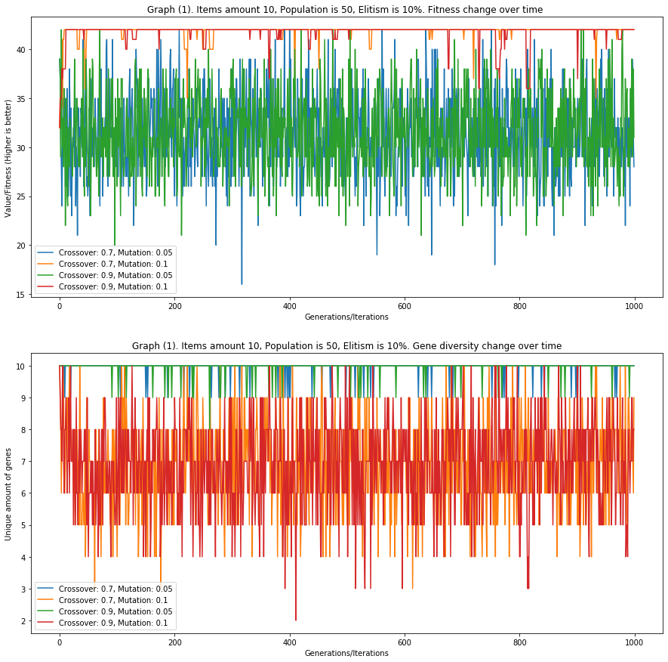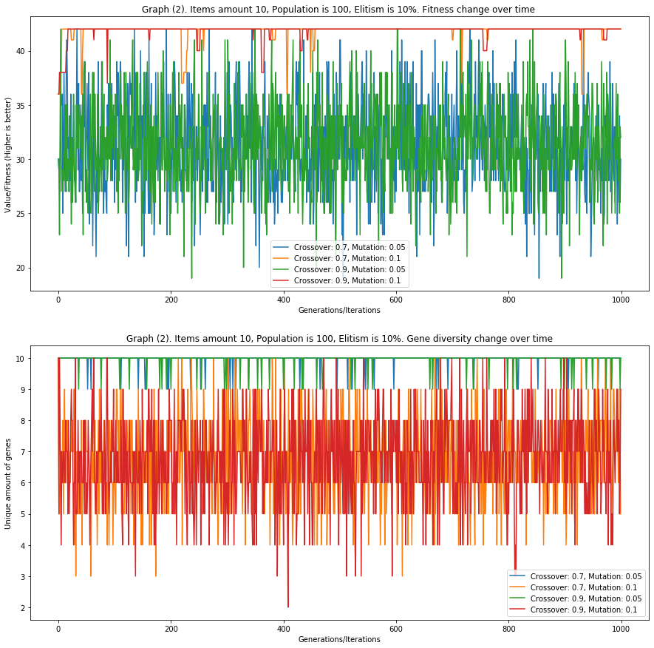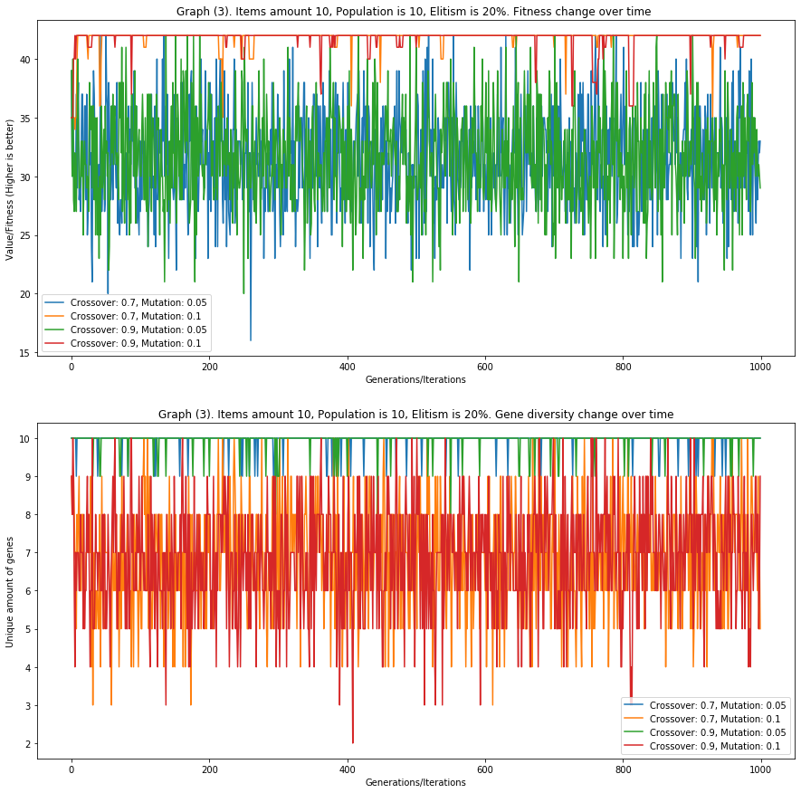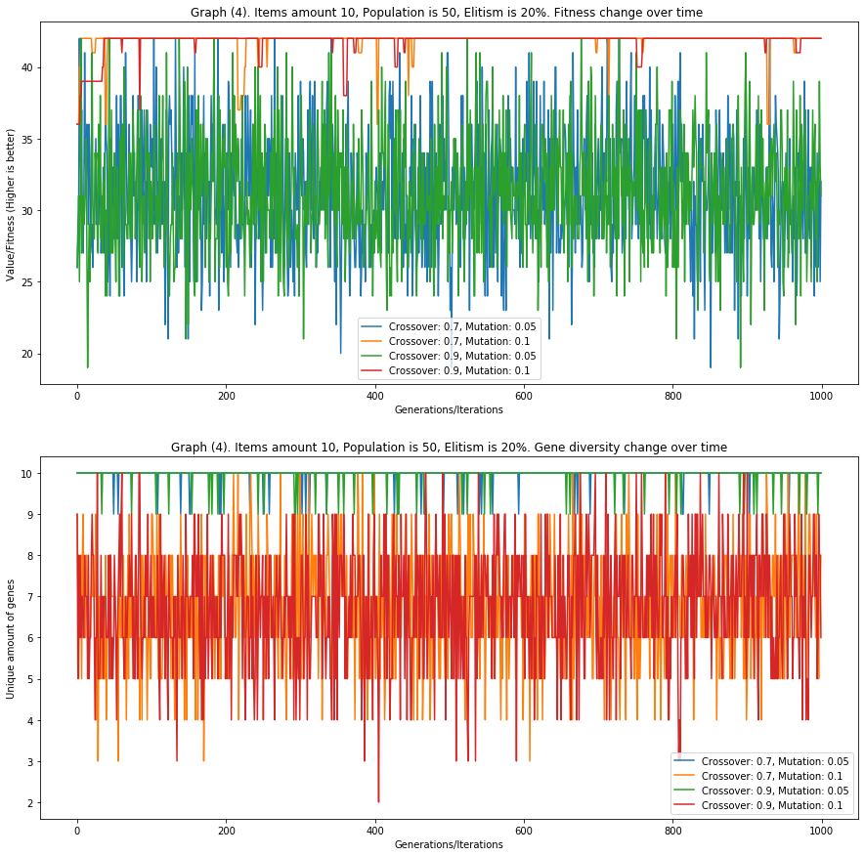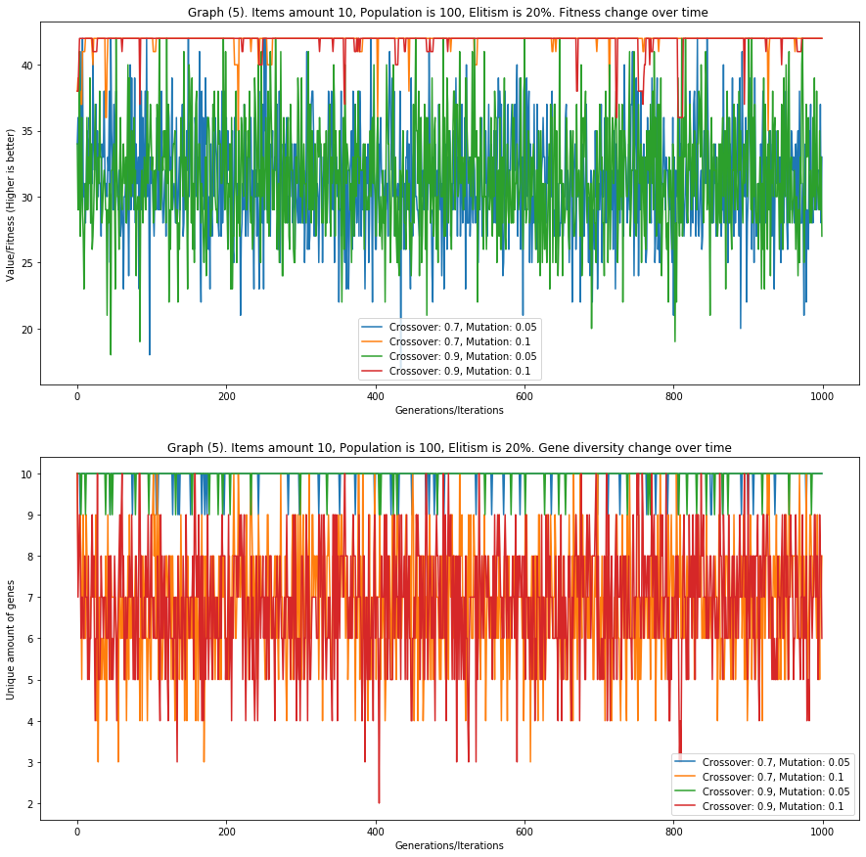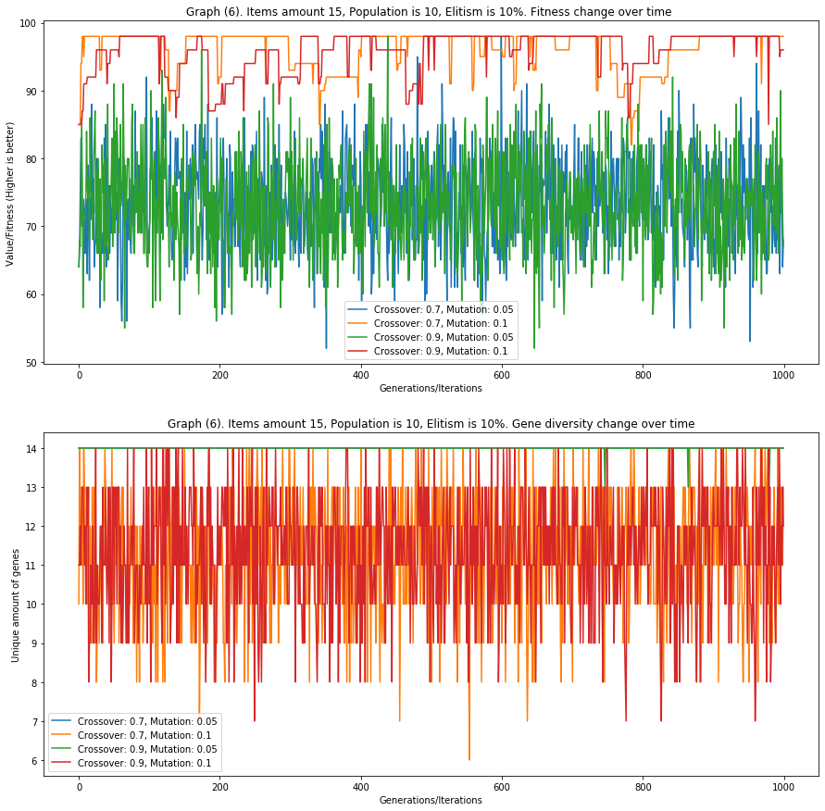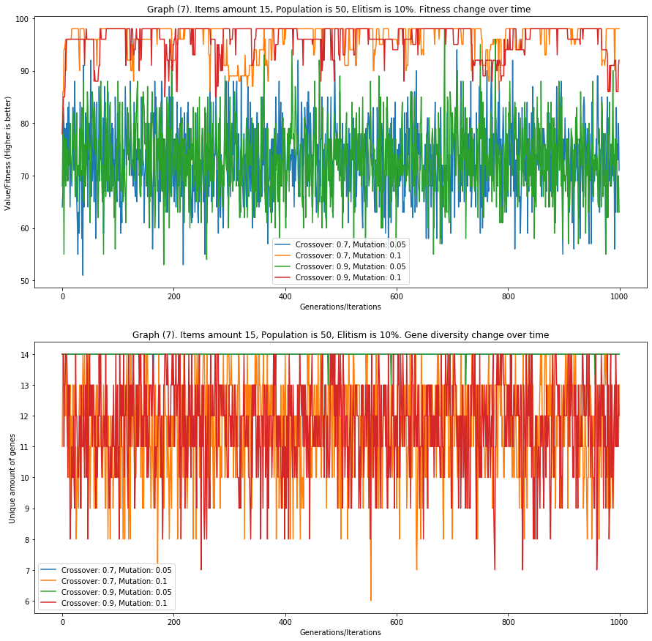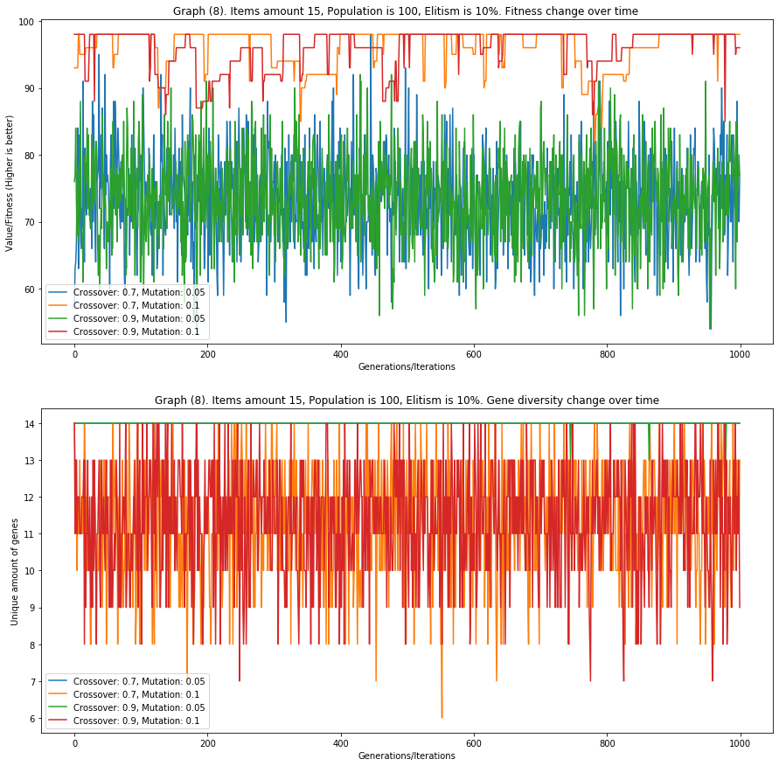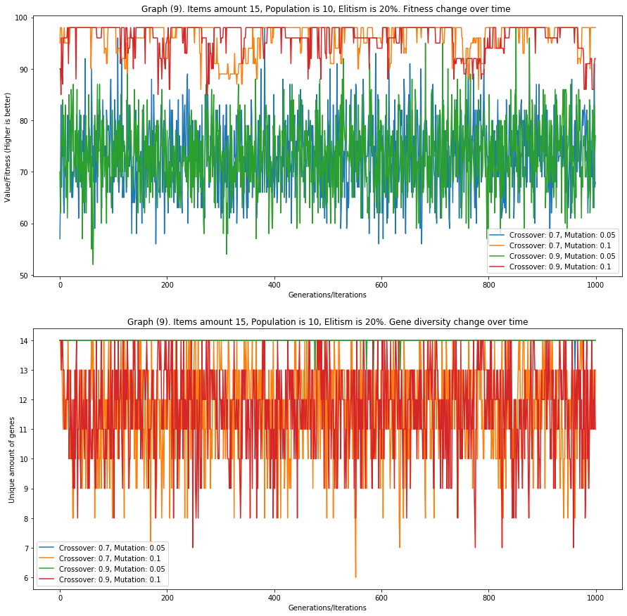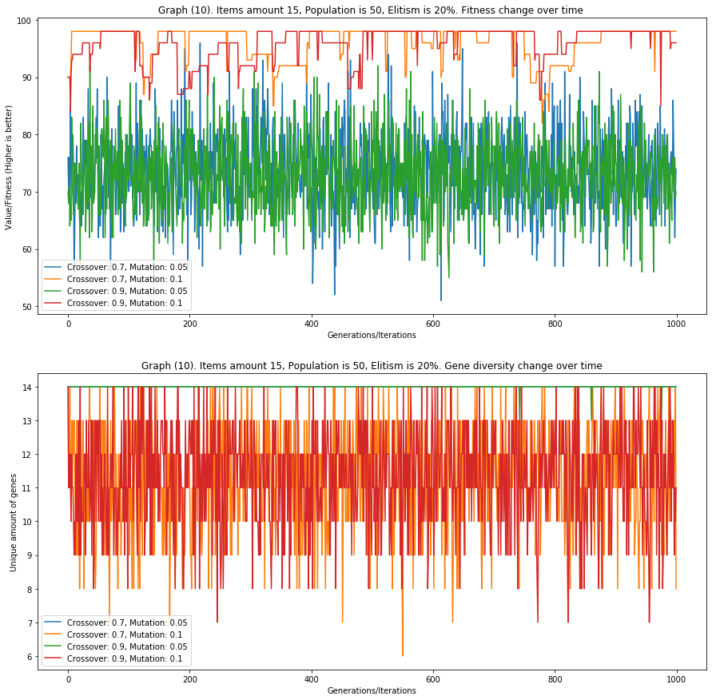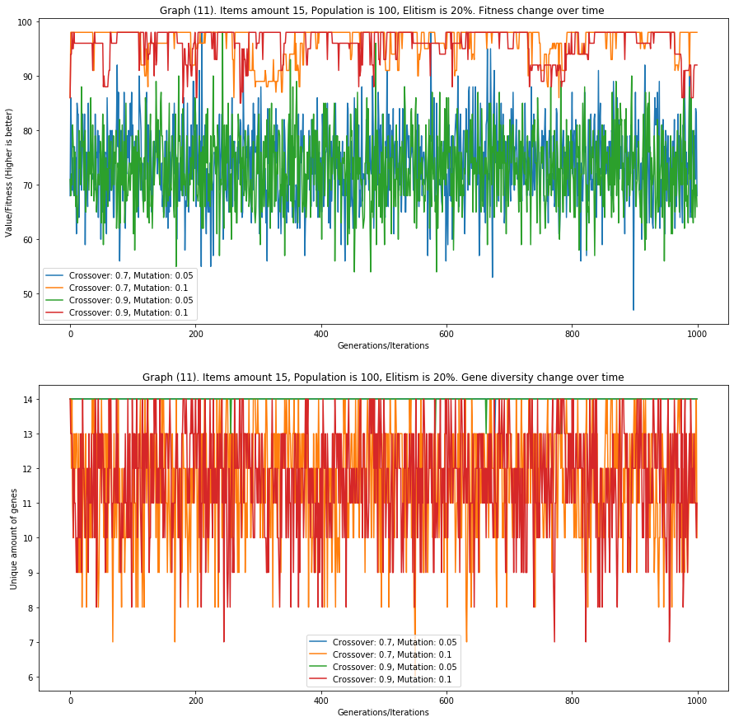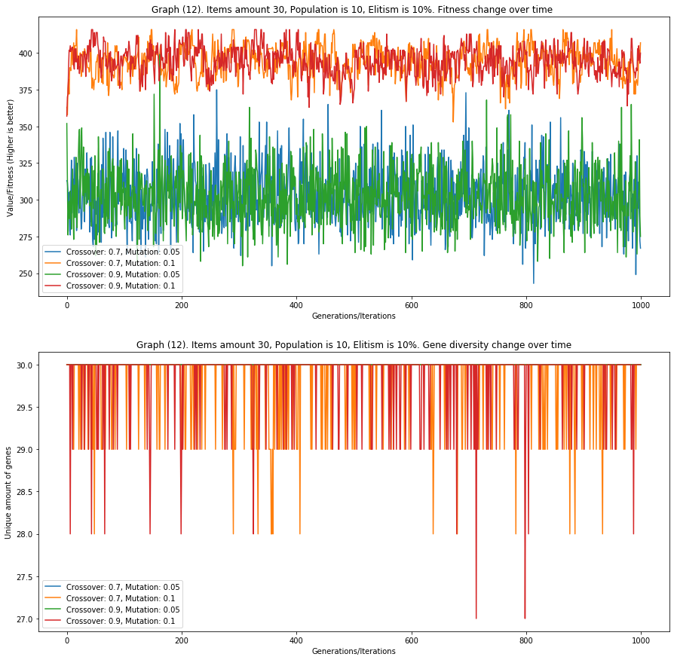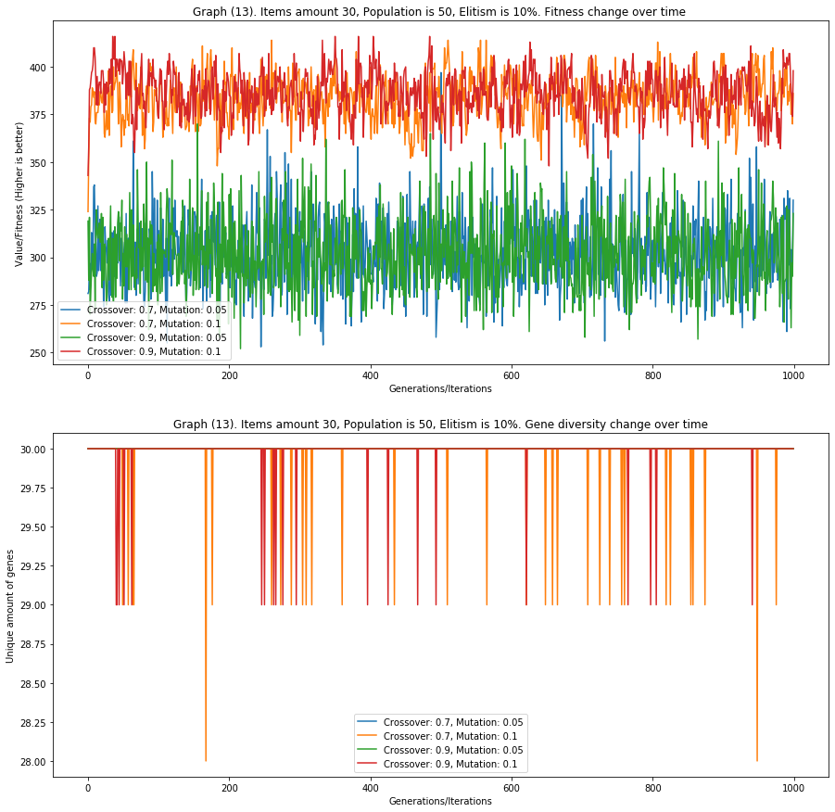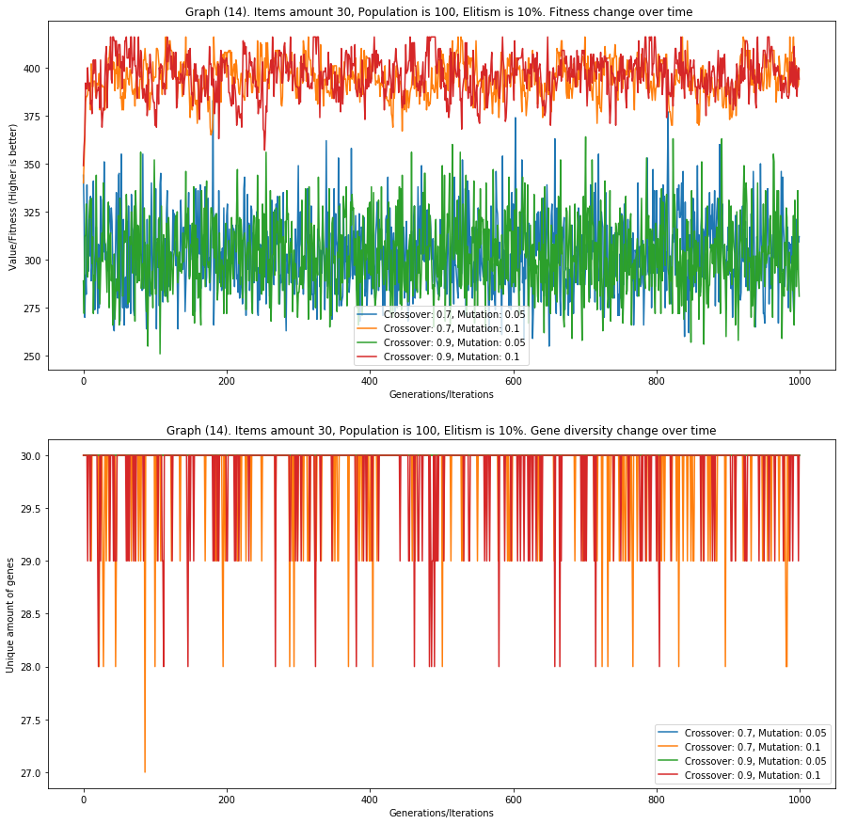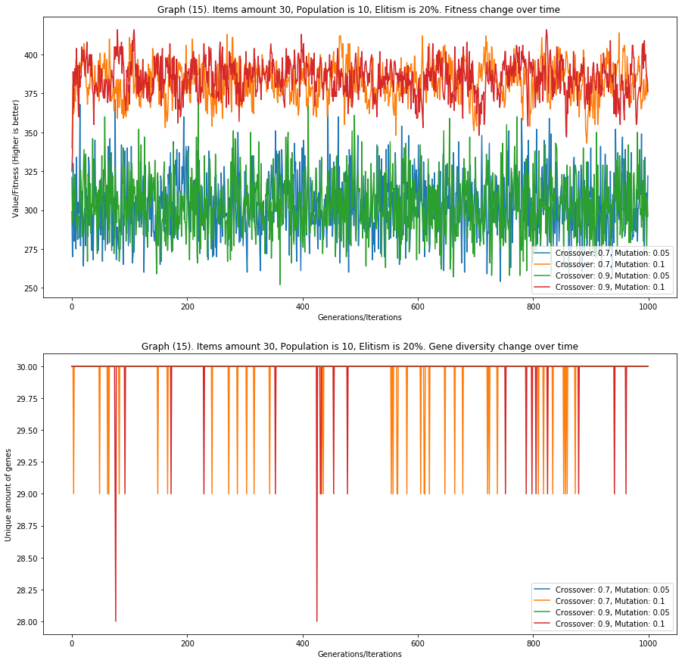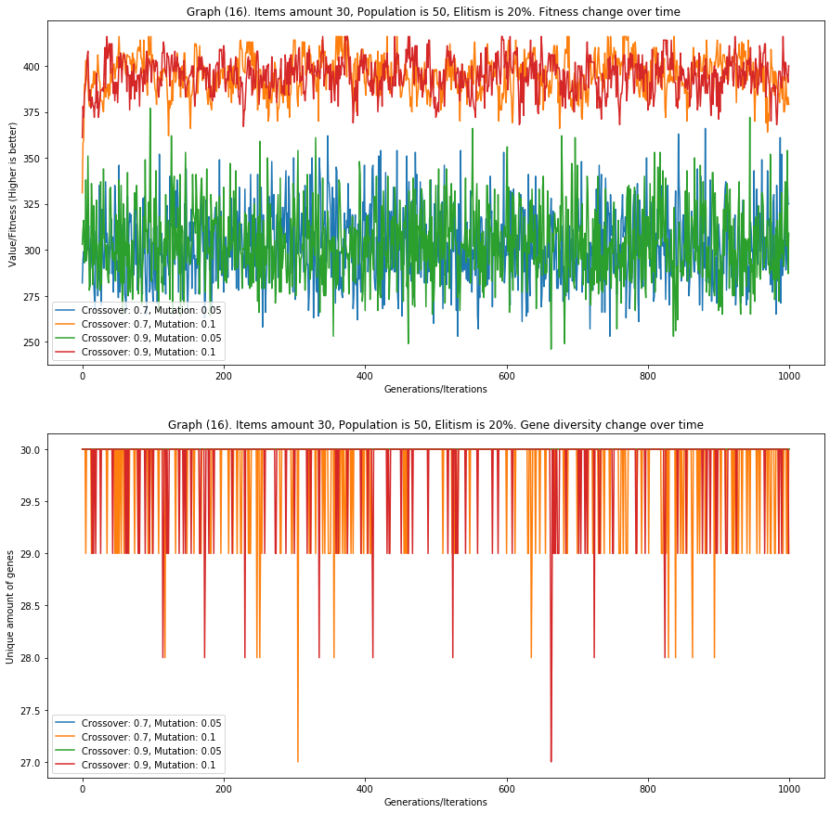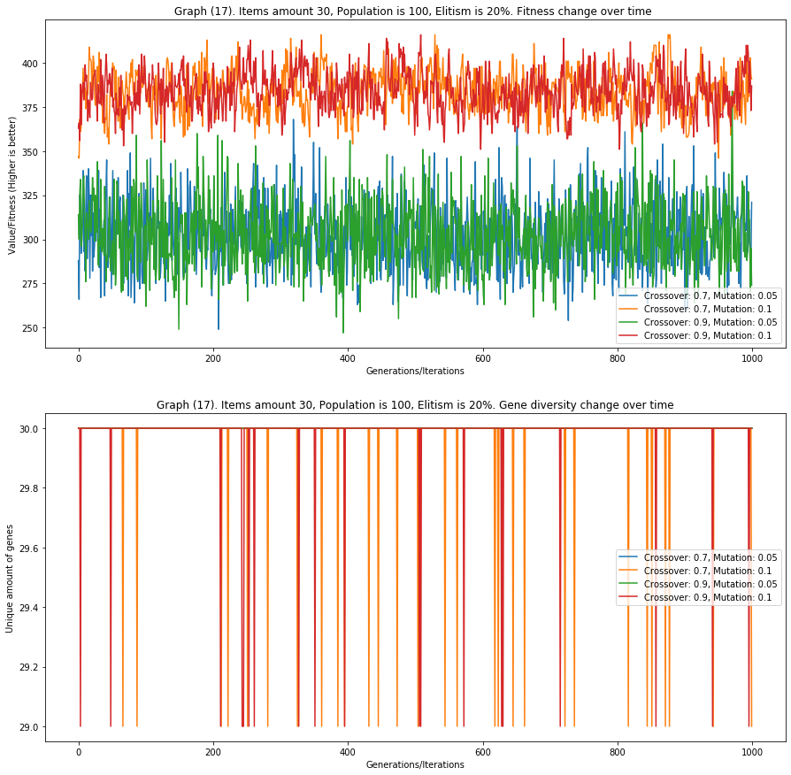

Experiments Graphs – TSP